**Name : AMAN UPADHYE**

**PRN : 202201050030**

**Roll no : 663**

**Division : F(F3)**

**Assignment 1A**

#Find the Stastical Analysis of Employee Record

f = open("/content/drive/MyDrive/Colab Notebooks/Emp01.csv","r")

contents = f.read()

lines = contents.split("\n")

eid = []; nm = []; desgn = []; sal = [];

for l in lines:

words = l.split(",")

print(words)

eid.append(int(words[0]))

nm.append(words[1])

desgn.append(words[2])

sal.append(int(words[3]))

print("Employee IDs : ",eid)

print("Employee Names : ",nm)

print("Employee Designations : ",desgn)

print("Employee Salaries : ",sal)

#Max Salary

print("Maximum Salary : ",max(sal))

#Employee whose Disignation is Manager

print("Employee whose Disignation is Manager : ",end='')

for i in range(len(desgn)):

if desgn[i] == "Manager" or desgn[i] =="manager" :

print(nm[i],end= " ")

#Employee whose Salary is 100000

print("Employee whose Salary is 100000 : ",nm[sal.index(100000)])

#Employee whose Salary is Minimum

print("\nEmployee whose Salary is Minimum : ",nm[sal.index(min(sal))])

#Employee whose Disignation is Supervisor

print("Employee whose Disignation is Supervisor : ",end='')

for i in range(len(desgn)):

if desgn[i] == "Supervisor" or desgn[i] =="supervisor" :

print(nm[i],end= " ")

f = 0

#Employee whose Salary is 50000

for i in range(len(sal)):

if sal[i] == 50000 :

print("\nEmployee whose Salary is 50000 : ",nm[i])

if(f==0):

print("\nNo Employee present whose Salary is 50000 ")

Output :

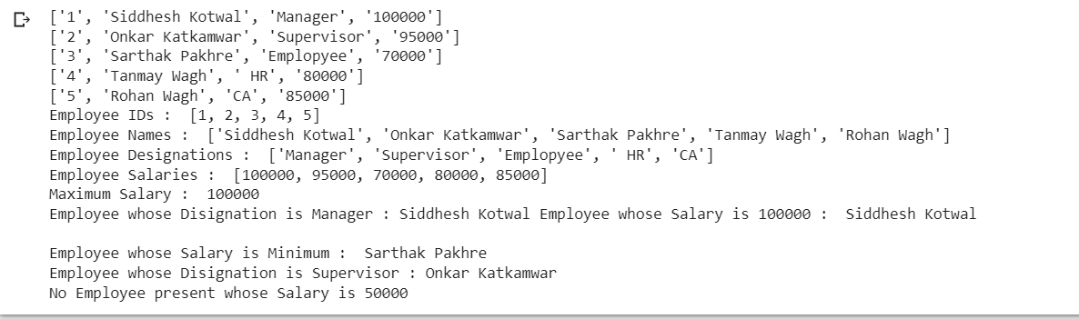

**Assignment 1B**

**Part 1:**

f1 = open ("/content/drive/MyDrive/Colab Notebooks/EmployeeA.txt","r")

f2 = open ("/content/drive/MyDrive/Colab Notebooks/EmployeeB.txt","r")

f3 = open ("/content/drive/MyDrive/Colab Notebooks/File Merged.csv","w")

contents1 = f1.read()

contents2 = f2.read()

print (contents1)

print (contents2)

nm = []

sal = []

lines1 = contents1.split("\n")

lines2 = contents2.split("\n")

for l1 in lines1:

  words1 = l1.split(",")

  for l2 in lines2:

    words2 = l2.split(",")

    if (words1[0] == words2[0] ):

      l1 = l1 +","+words2[1]+","+words2[2]+"\n"

      f3.write(l1)

      nm.append(words1[1])

      sal.append(int(words2[2]))

      print(l1)

f1.close()

f2.close()

f3.close()

#Max Salary

print("Maximum Salary : ",max(sal))

    #Employee whose Salary is 50000

for i in range(len(sal)):

  if sal[i] == 50000 :

    print("\nEmployee whose Salary is 50000 : ",nm[i])

OUTPUT :

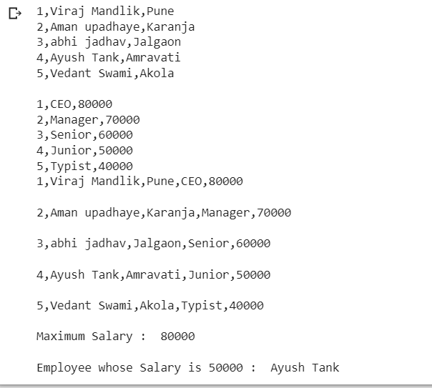

**Part 2 :**

import csv

def top_5_emp(d3):

  d3.sort(key = lambda x : int(x[5]), reverse = True)

  print("Sorted Data : ",d3)

  print("\n\nTop 1 Employee",d3[0][1])

  print("\n\nTop 2 Employee",d3[1][1])

  print("\n\nTop 3 Employee",d3[2][1])

  print("\n\nTop 4 Employee",d3[3][1])

  print("\n\nTop 5 Employee",d3[4][1])

f1 = open ("/content/drive/MyDrive/Colab Notebooks/EmployeeA.txt","r")

f2 = open ("/content/drive/MyDrive/Colab Notebooks/EmployeeB.txt","r")

f3 = open ("/content/drive/MyDrive/Colab Notebooks/File Merged.csv","w")

d1 = list(csv.reader(f1,delimiter=','))

d2 = list(csv.reader(f2,delimiter=','))

print("\n\n File1 Contents : ",d1)

print("\n\n File2 Contents : ",d2)

d3 = []

for i in range(len(d1)):

  d3.append(d1[i] + d2[i])

print(d3)

cw = csv.writer(f3)

cw.writerows(d3)

top_5_emp(d3)

f1.close()

f2.close()

f3.close()

#Max Salary

print("Maximum Salary : ",max(sal))

    #Employee whose Salary is 50000

for i in range(len(sal)):

  if sal[i] == 50000 :

    print("\nEmployee whose Salary is 50000 : ",nm[i])

OUTPUT :

